AWS S3 Project

1: S3 Bucket Create

Step 1: Login
AWS Console → Services → S3

Step 2: Create Bucket
- Bucket name: madhuri-s3-practical-001 (globally unique)
- Block all public access → ON (default)
Create Bucket
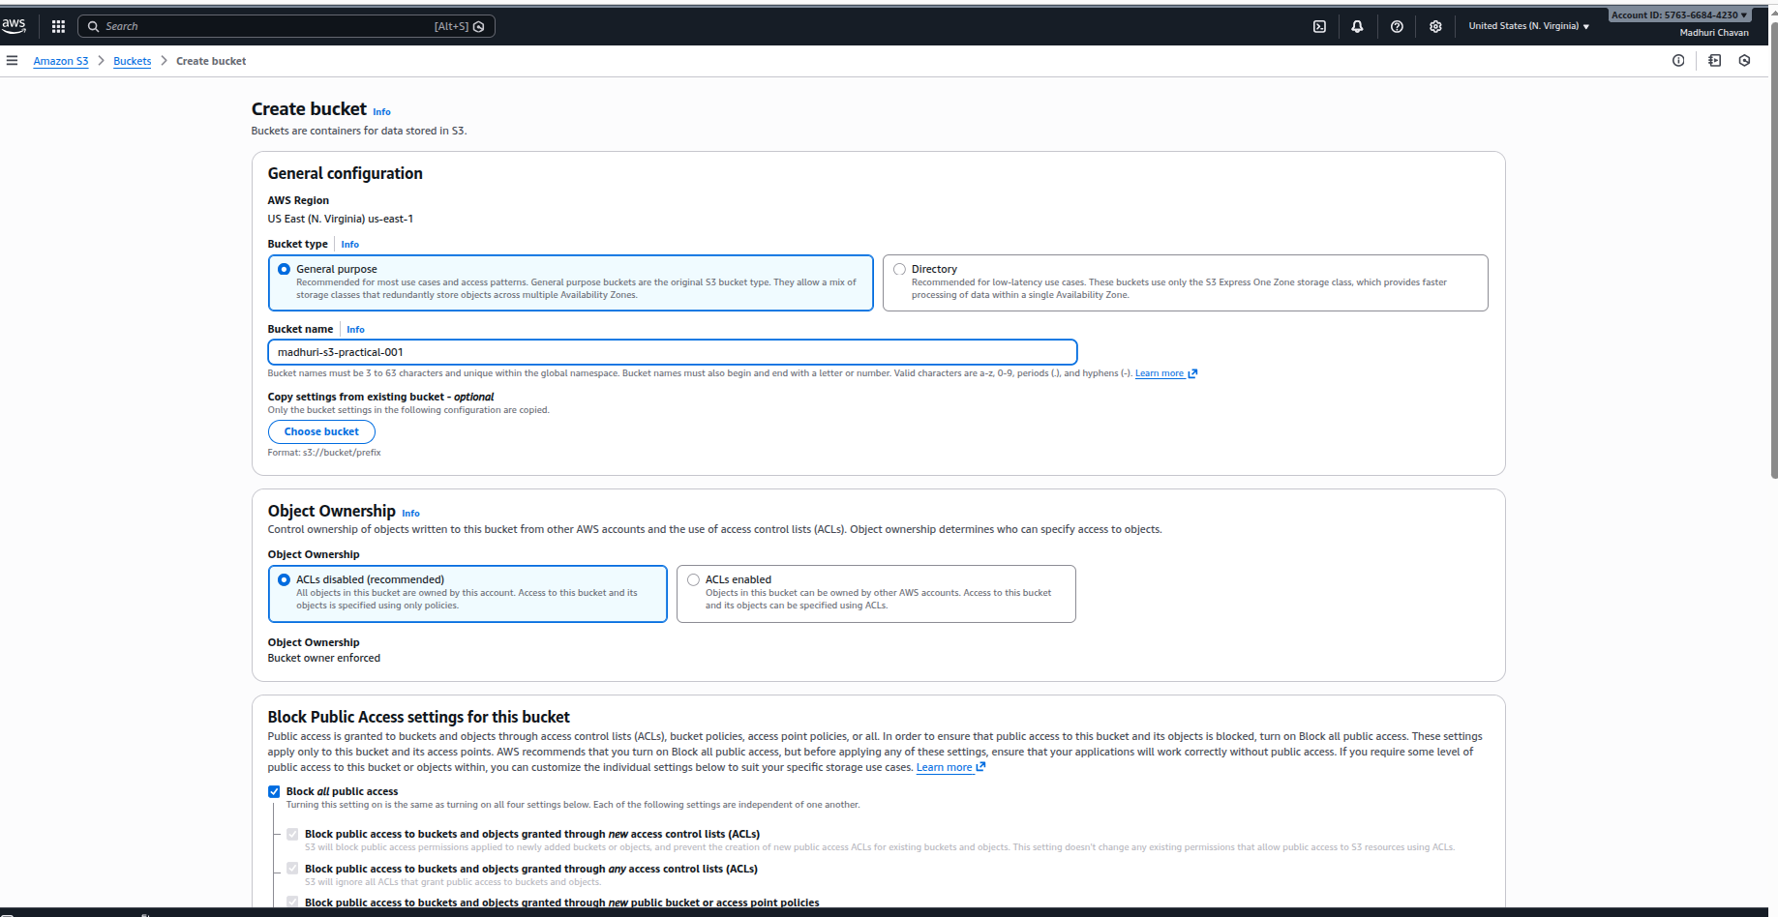

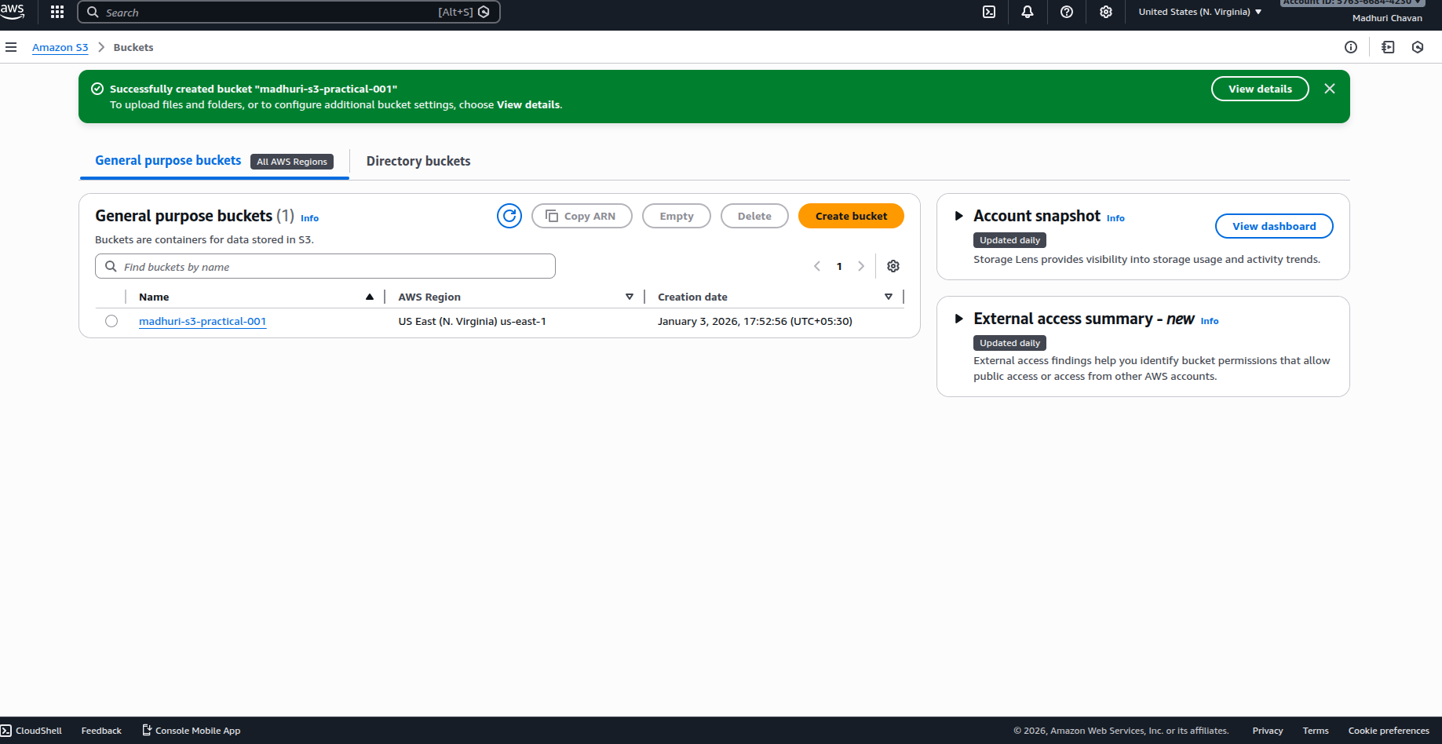

2: File Upload & Download
Upload
  - Open bucket
  - Upload → Add files
  - add file
  - Upload
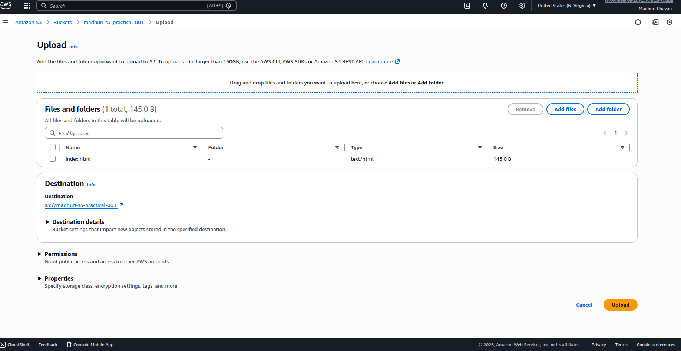
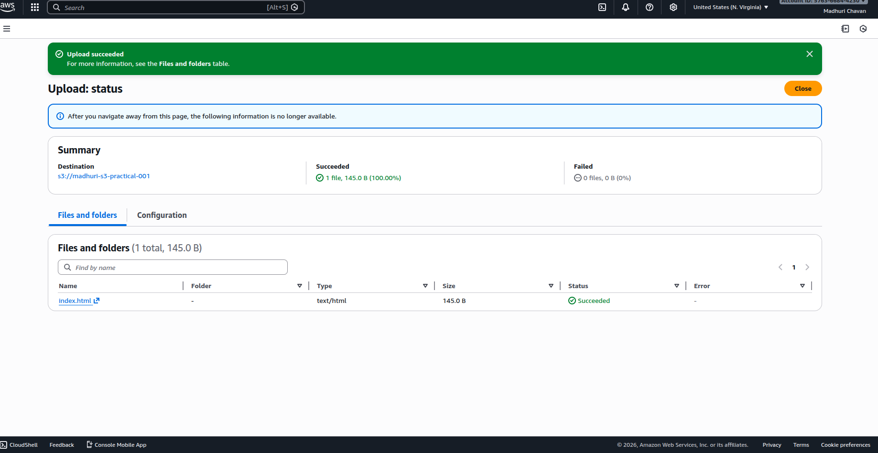
Download
- File selects
- Download
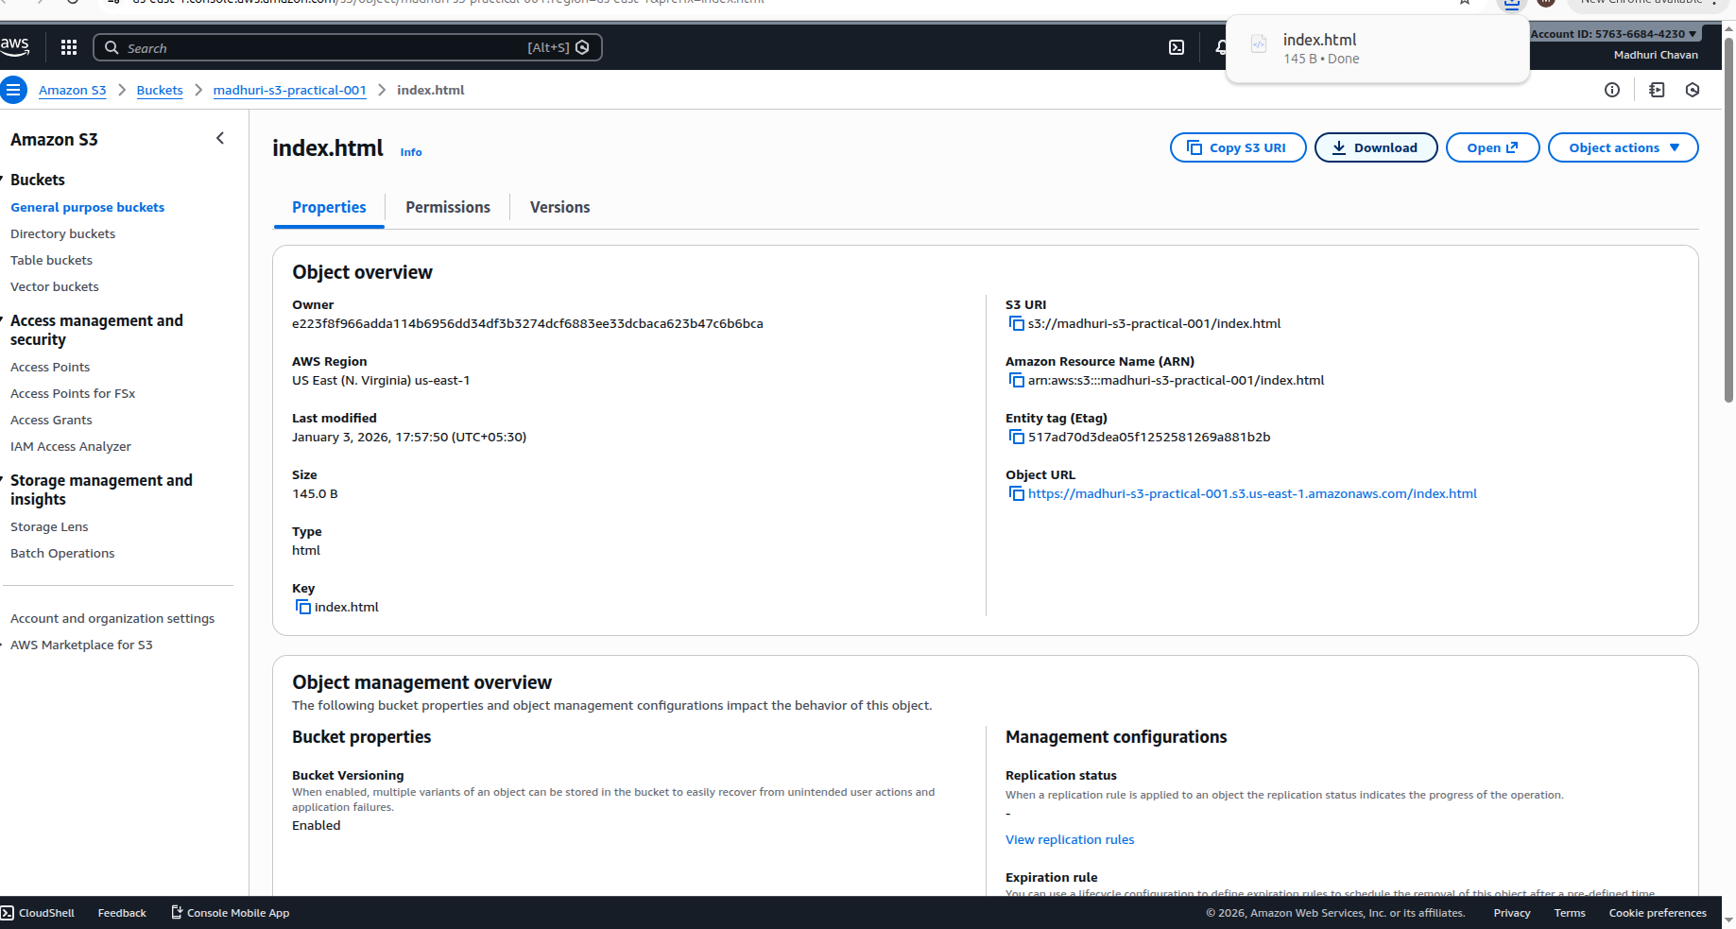

3: Public Access (Static file)

Step 1: Disable block public access
- Bucket → Permissions
- Block public access → Edit → Unchecked all
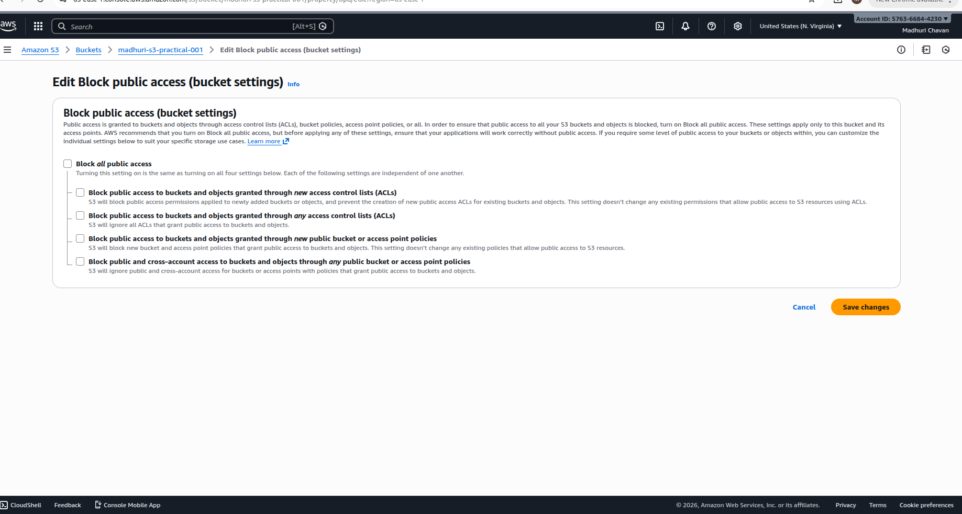

Step 2: Bucket Policy add
Permissions → Bucket Policy → Paste:

{
"Version": "2012-10-17",
"Statement": [
{
"Sid": "PublicRead",
"Effect": "Allow",
"Principal": "*",
"Action": "s3:GetObject",
"Resource": "arn:aws:s3:::madhuri-s3-practical-001/*"
}
]
}
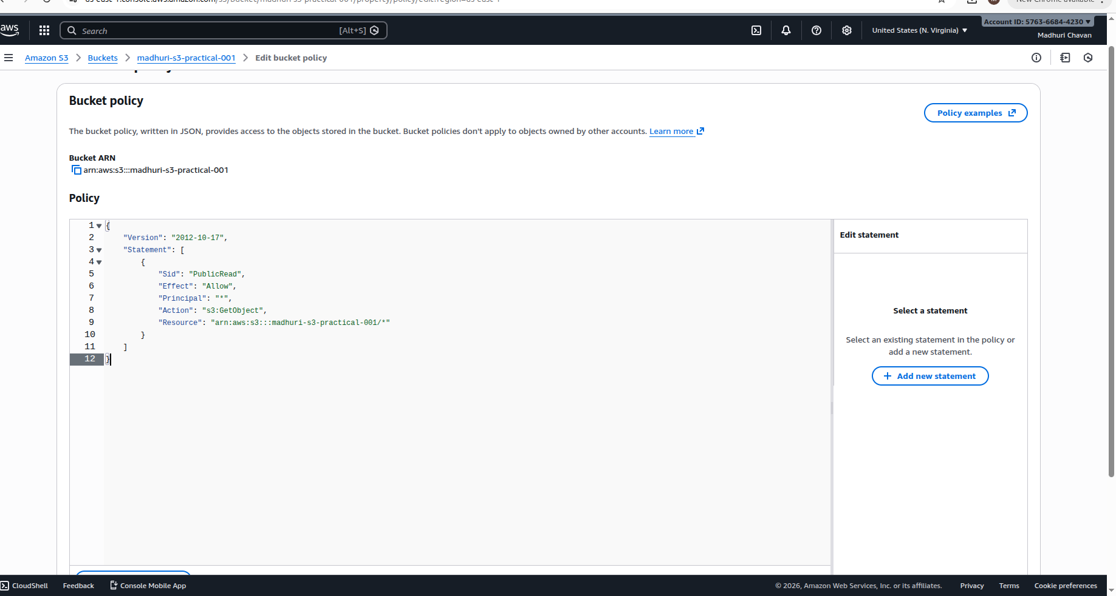

Step 3: File URL test
- Open object
- Paste Object URL in browser
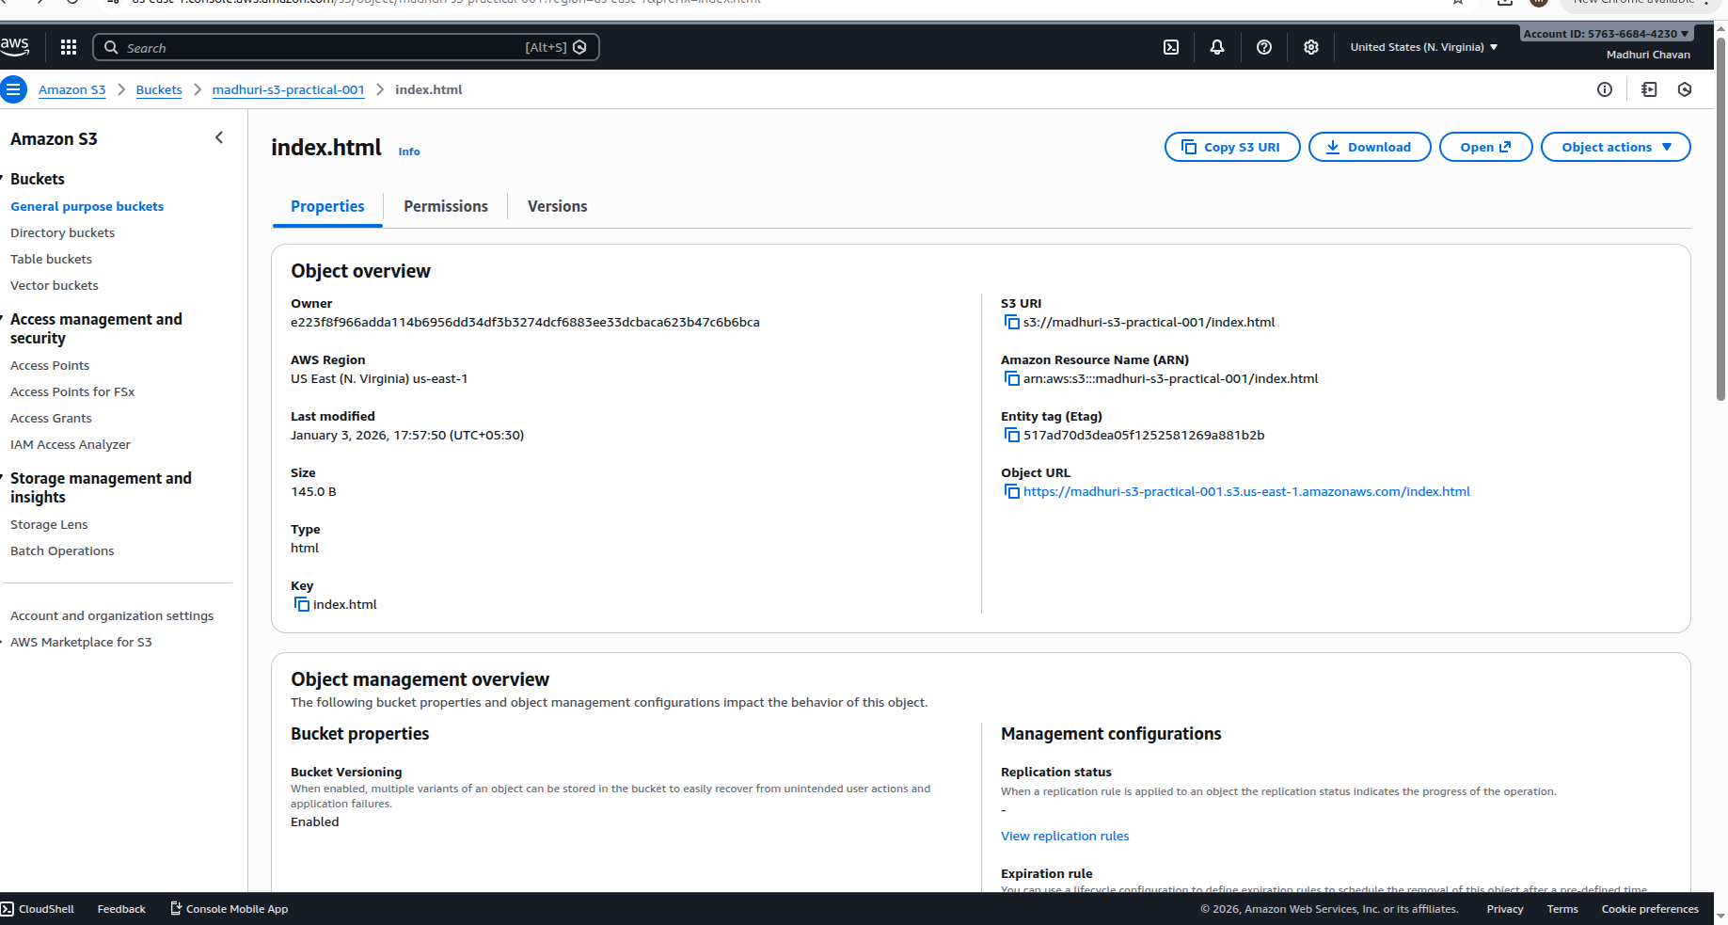
File open = success
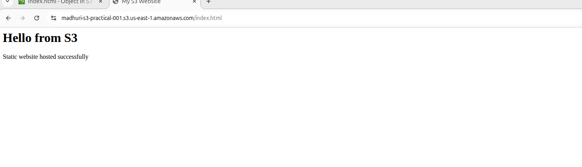

4: Versioning

Enable Versioning
- Bucket → Properties
- Bucket Versioning → Enable
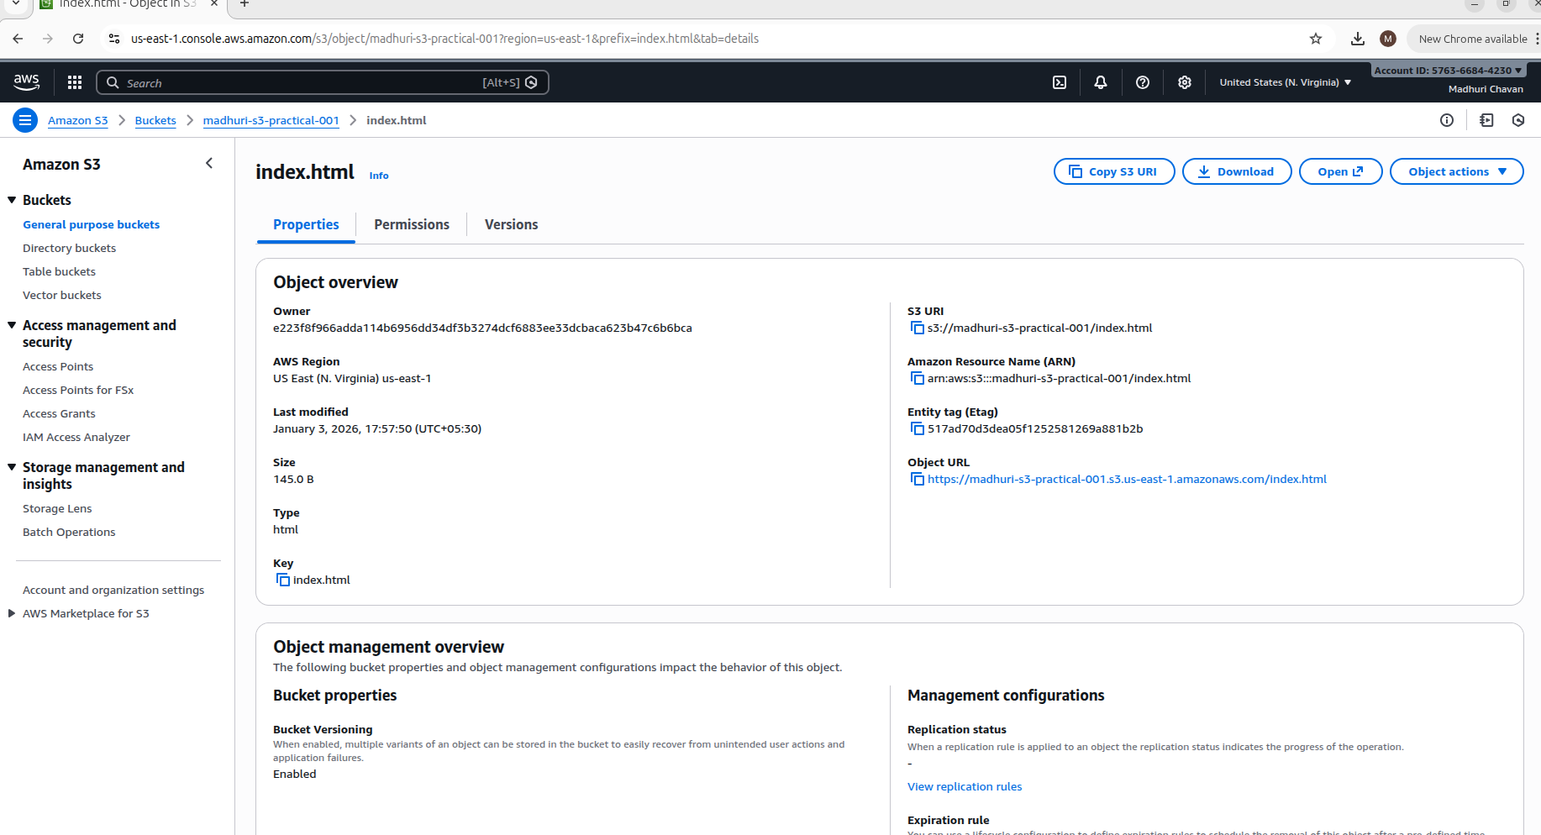
- Index.html edit (content change)
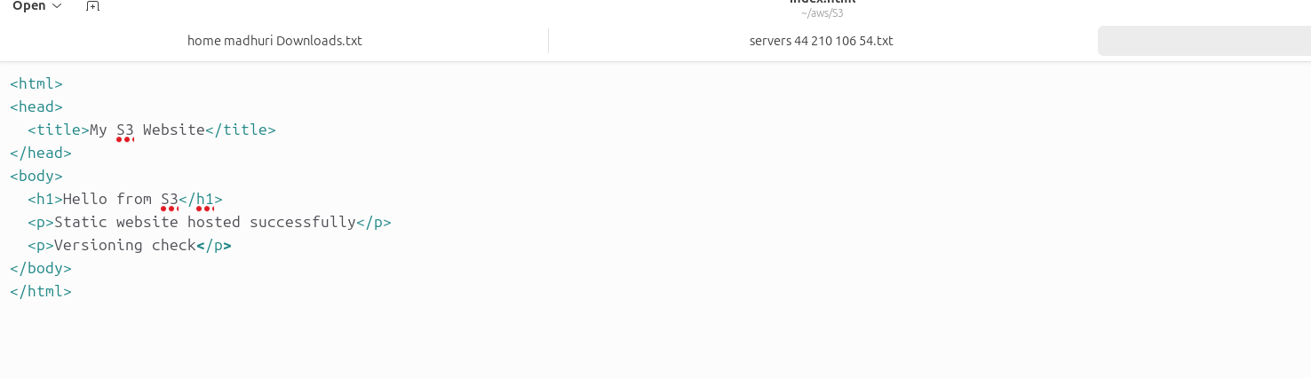

- upload again
In Versions tab multiple versions will visible
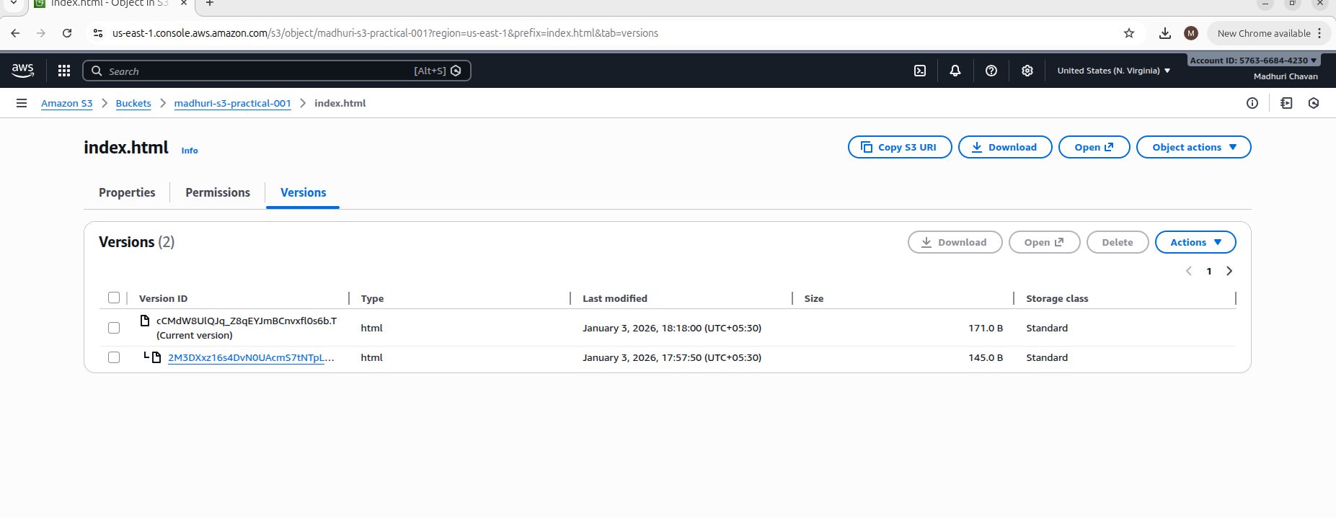
Use-case:
Accidental delete / overwrite recovery

5: Life cycle Rule (Cost Saving)

Create Rule
- Bucket → Management → Lifecycle rules → Create
- Rule name: move-to-ia
- Apply to all objects
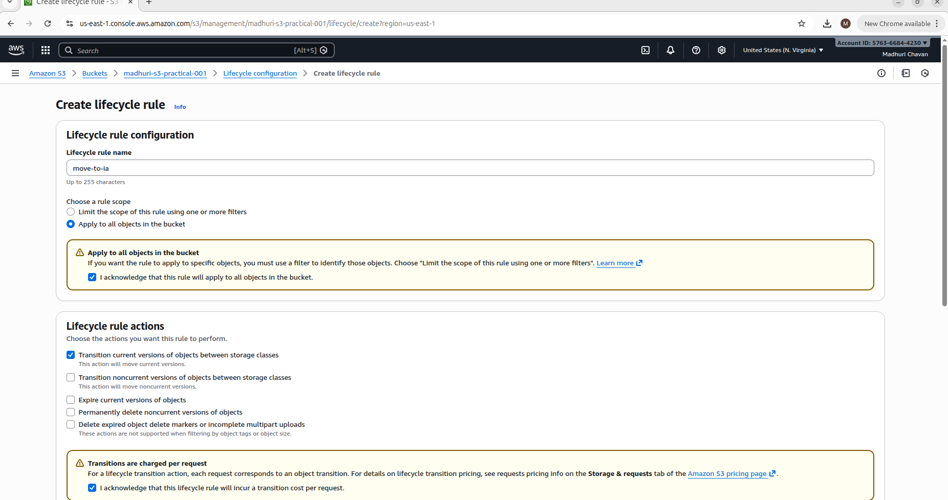

- Transition:
  - After 30 days → Standard-IA
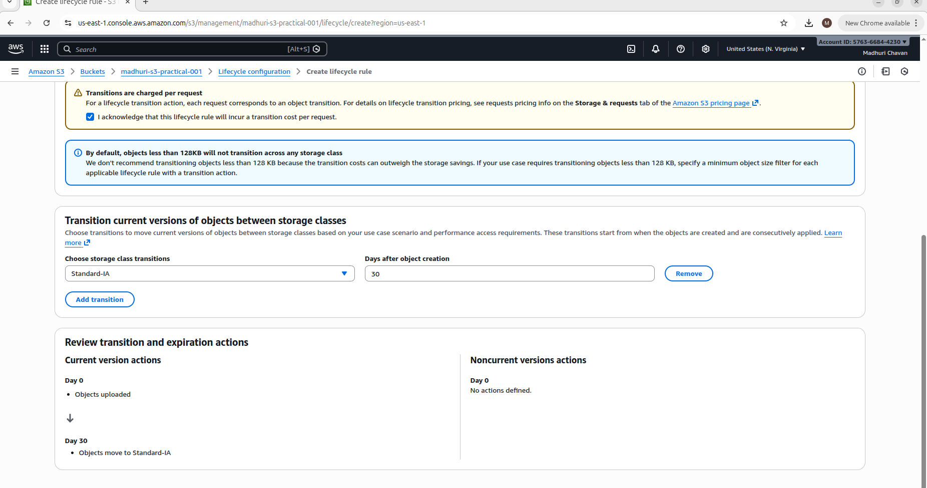
Save
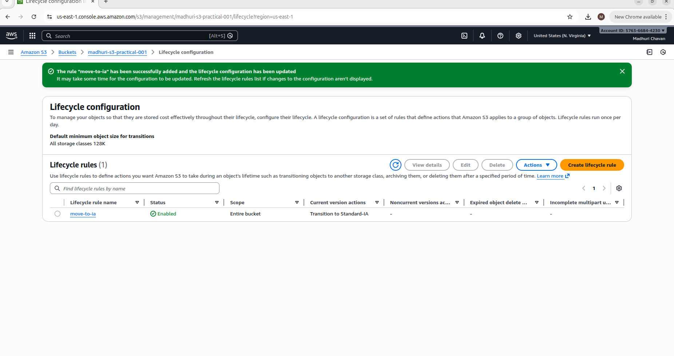
💡 Real-world:
Old logs, backups goes in cheaper storage

6: AWS CLI + S3 (REAL DEVOPS)

Step 1: AWS CLI install (Ubuntu)
- sudo apt update
- sudo apt install awscli -y

Step 2: Configure
- aws configure
Enter:
- Access Key
- Secret Key
- Region: ap-south-1
- Output: json

Upload file using CLI
- aws s3 cp test.txt s3://madhuri-s3-practical-001/

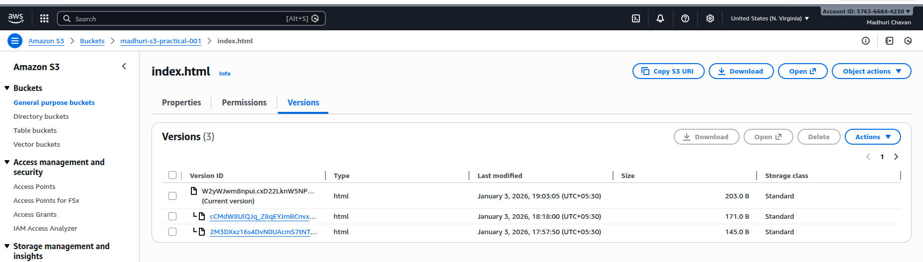

List files
- aws s3 ls s3://madhuri-s3-practical-001/

7: S3 + IAM Policy

Goal
- Create IAM user
- Only one S3 bucket access
- Console + CLI verify

STEP 1: IAM User Create
AWS Console → IAM → Users → Create user
- Username: s3-user-demo
- Access type:
  - ✅ Programmatic access
  - ✅ AWS Management Console access
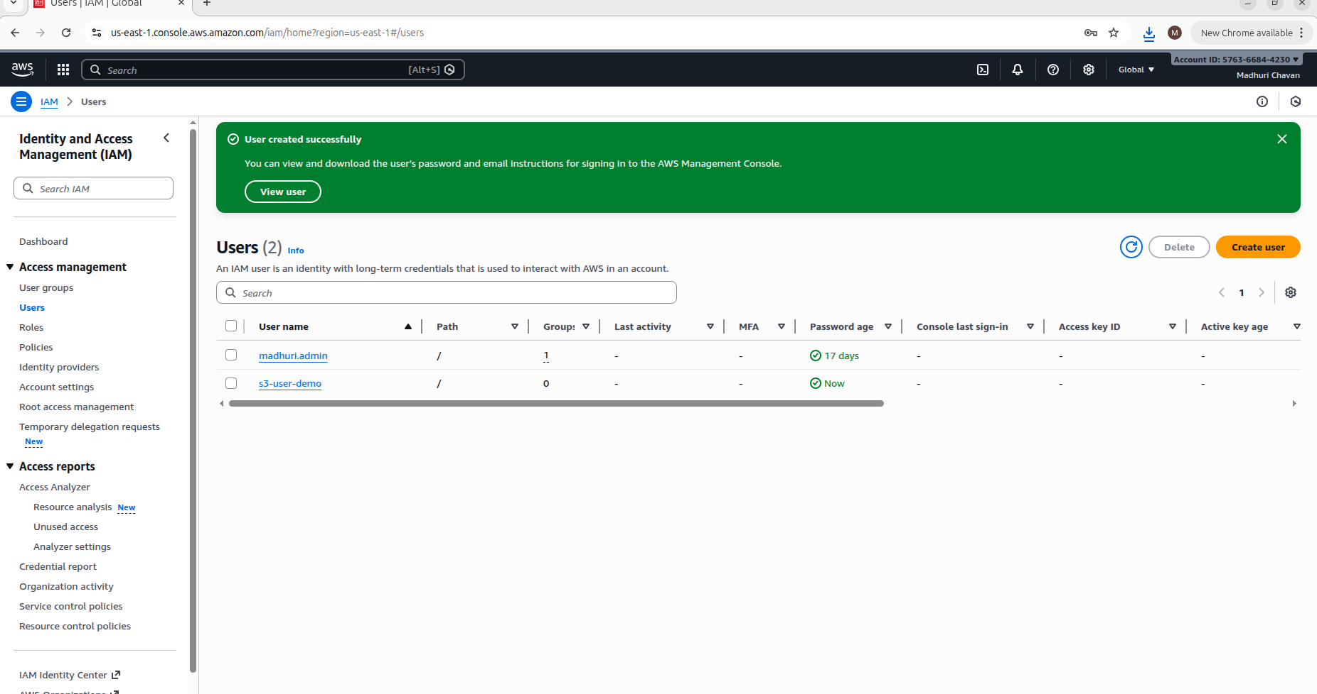

STEP 2: Custom IAM Policy (Important)
IAM → Policies → Create Policy → JSON tab
Bucket name → madhuri-s3-practical-001

Policy (ONLY that bucket access)

{
"Version": "2012-10-17",
"Statement": [
{
"Effect": "Allow",
"Action": "s3:ListAllMyBuckets",
"Resource": "*"
},
{
"Effect": "Allow",
"Action": "s3:ListBucket",
"Resource": "arn:aws:s3:::madhuri-s3-practical-001"
},
{
"Effect": "Allow",
"Action": [
"s3:GetObject",
"s3:PutObject",
"s3:DeleteObject"
],
"Resource": "arn:aws:s3:::madhuri-s3-practical-001/*"
}
]
}

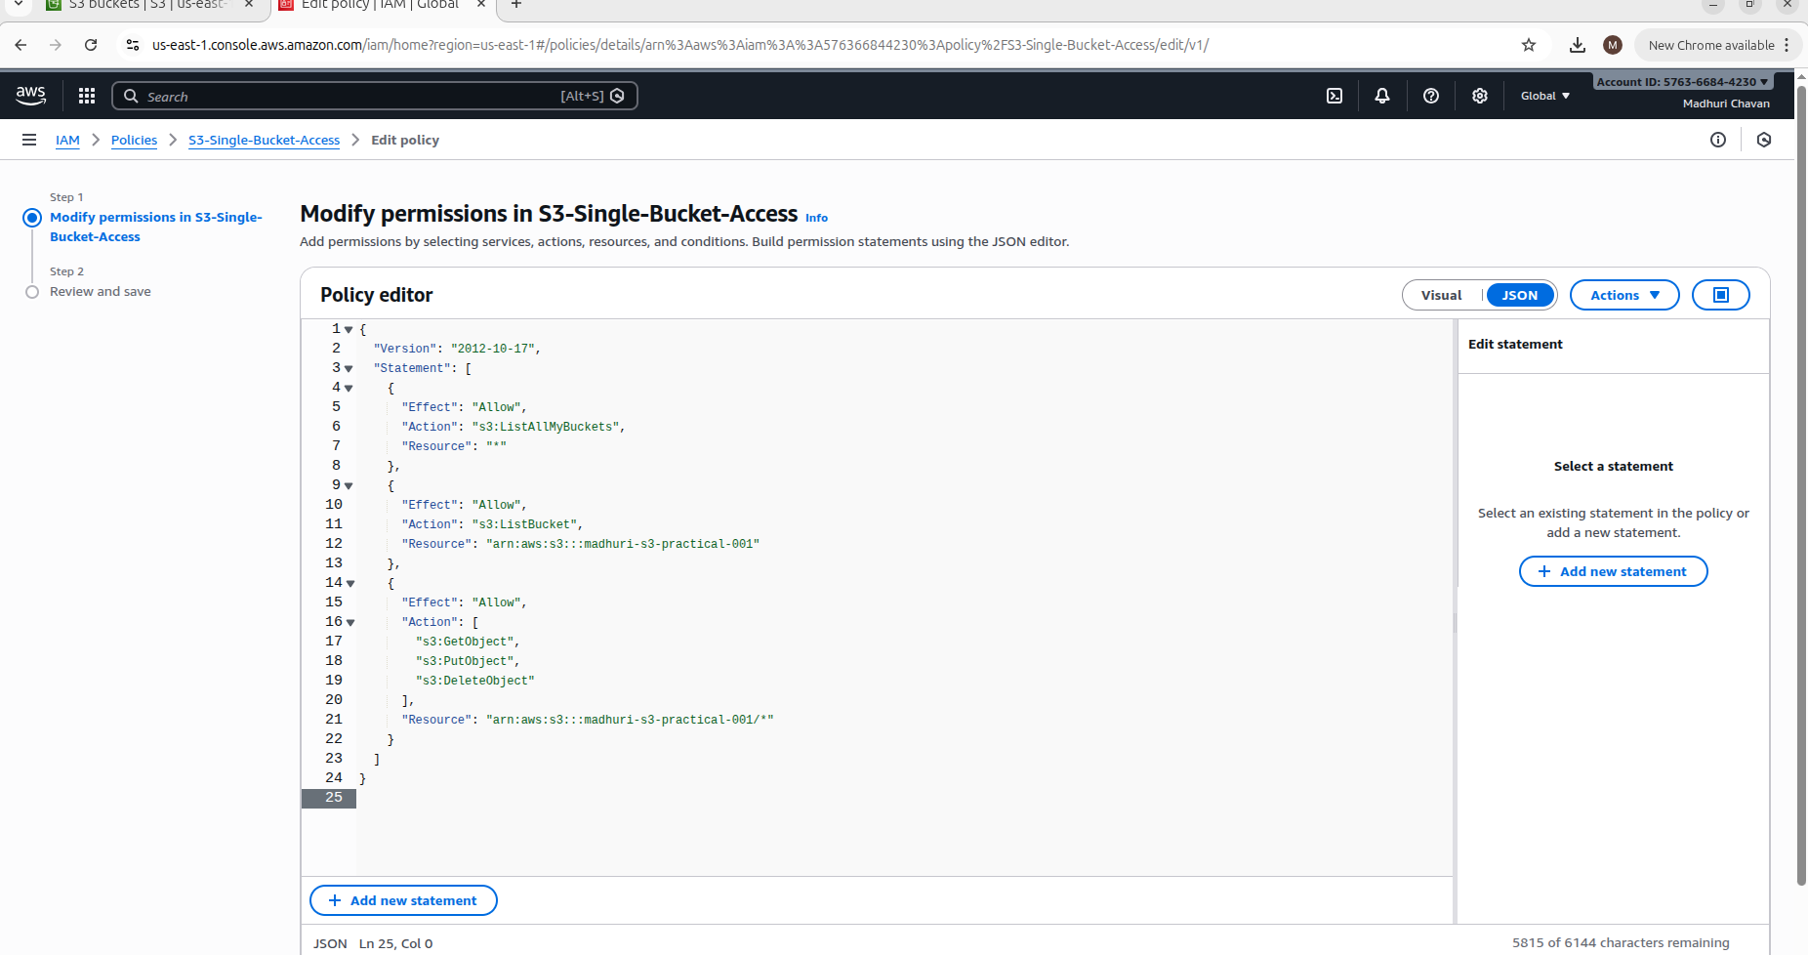
Policy name: S3-Single-Bucket-Access
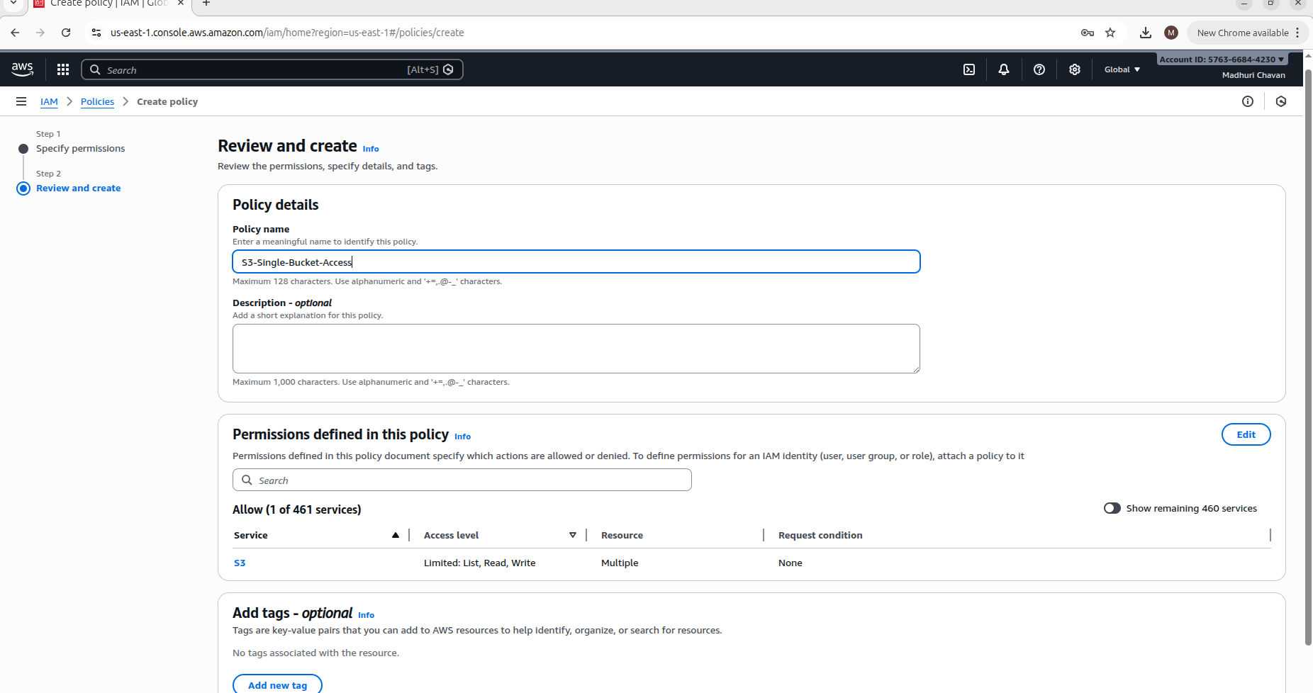
Create Policy

STEP 3: Attach Policy to User
IAM → Users → s3-user-demo
Permissions → Add permissions → Attach existing policy
Select S3-Single-Bucket-Access
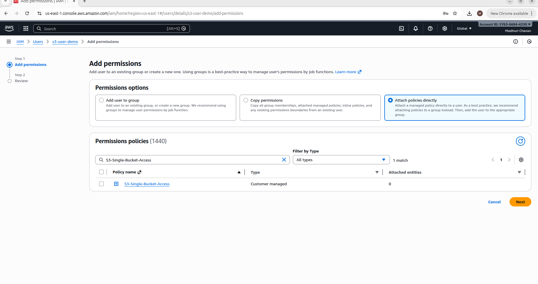

STEP 4: Verification

Console Test
- Logout root
- Login using s3-user-demo
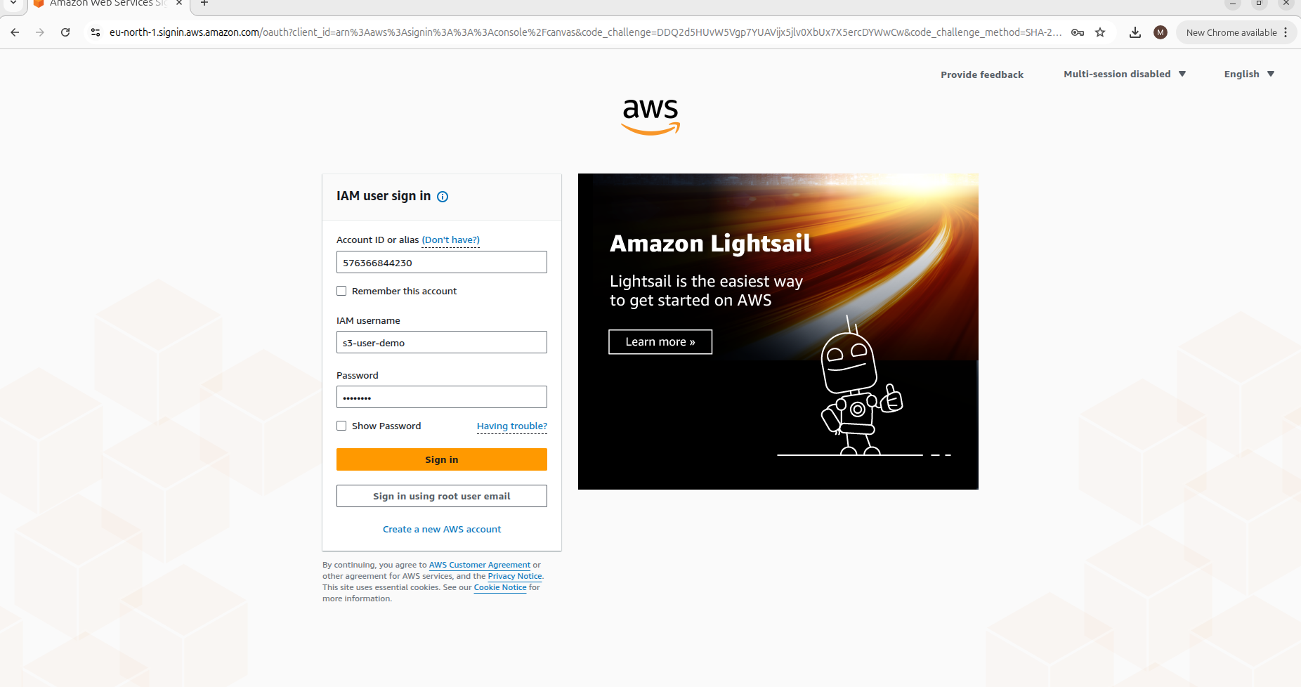
- S3 open
👉 Only one bucket
👉 Others = Access Denied
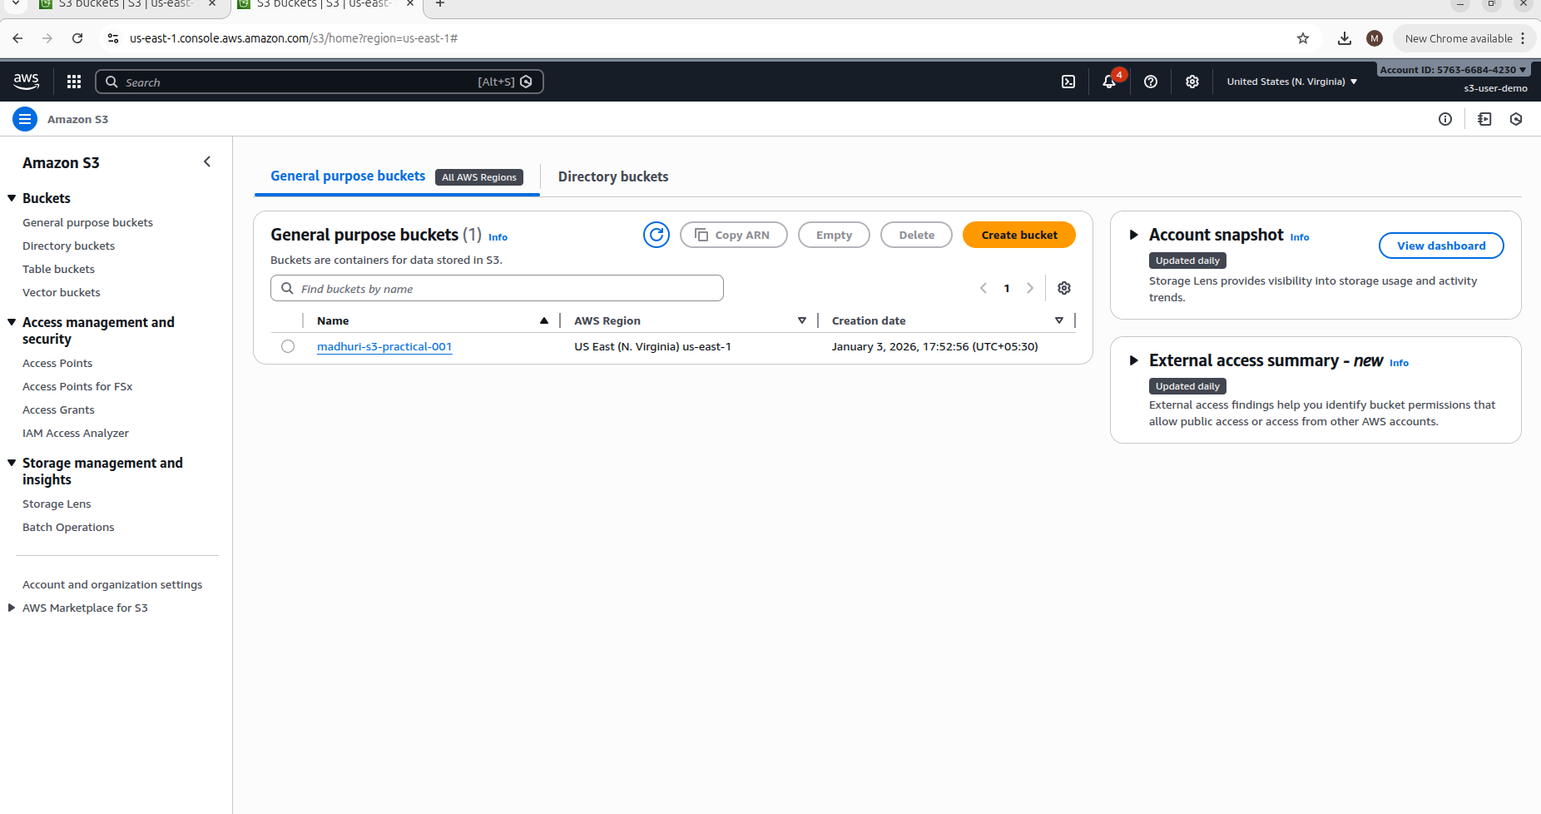

CLI Test
- aws configure
- aws s3 ls
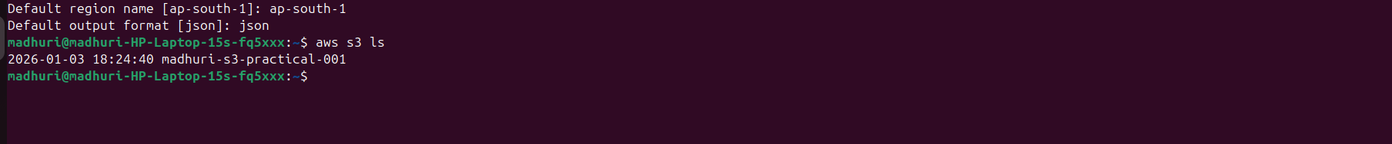

8: S3 Static Website Hosting Practical

Goal
- HTML website host
- Browser URL open

STEP 1: HTML File Create

<!-- index.html -->
<html>
<head>
<title>My S3 Website</title>
</head>
<body>
<h1>Hello from S3</h1>
<p>Static website hosted successfully</p>
</body>
</html>

STEP 2: Upload Files
Bucket → Upload
- index.html

STEP 3: Enable Static Website Hosting
Bucket → Properties
Scroll → Static website hosting
- Enable
- Hosting type: Static website
- Index document: index.html
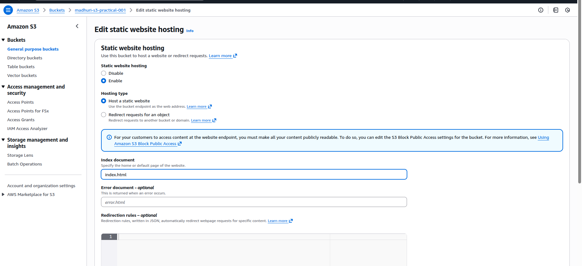
👉 Save

STEP 4: Public Access Allow

Disable Block Public Access
Bucket → Permissions
Block public access → Disable ALL

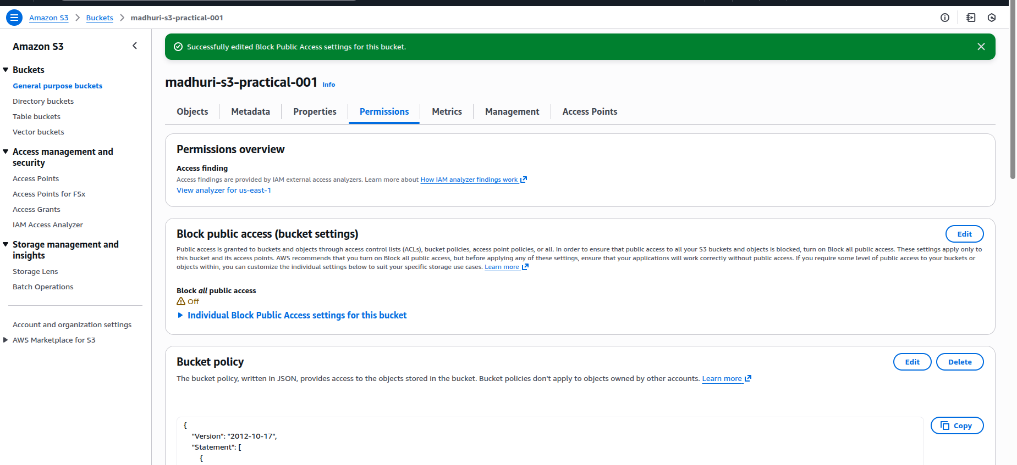

Bucket Policy (Website Access)
{
"Version": "2012-10-17",
"Statement": [
{
"Effect": "Allow",
"Principal": "*",
"Action": "s3:GetObject",
"Resource": "arn:aws:s3:::madhuri-s3-practical-001/*"
}
]
}

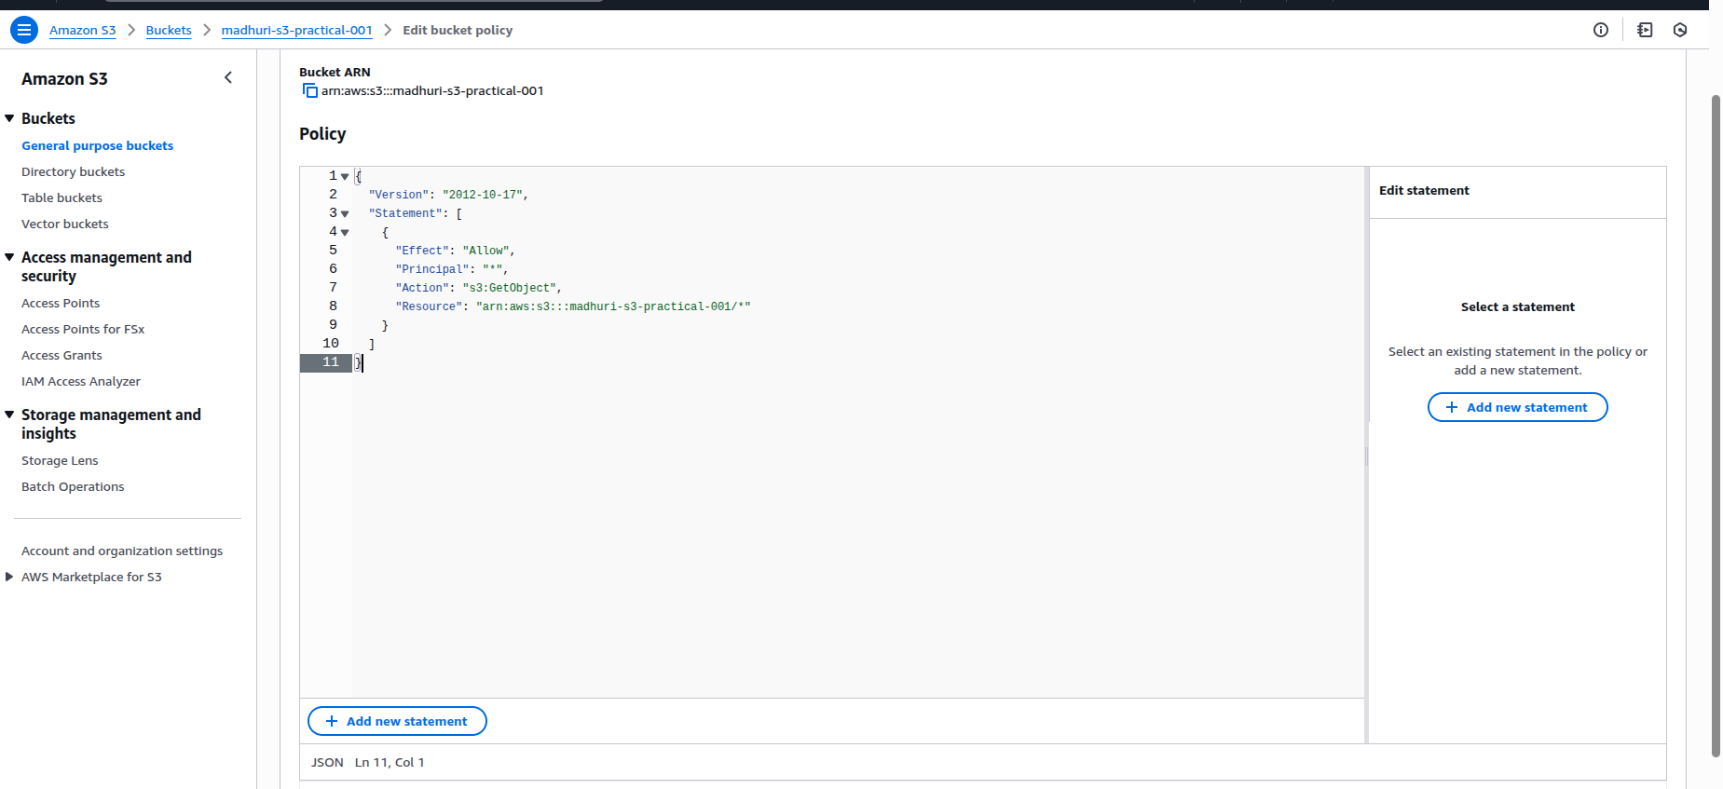

STEP 5: Website URL Test
Properties → Static website hosting
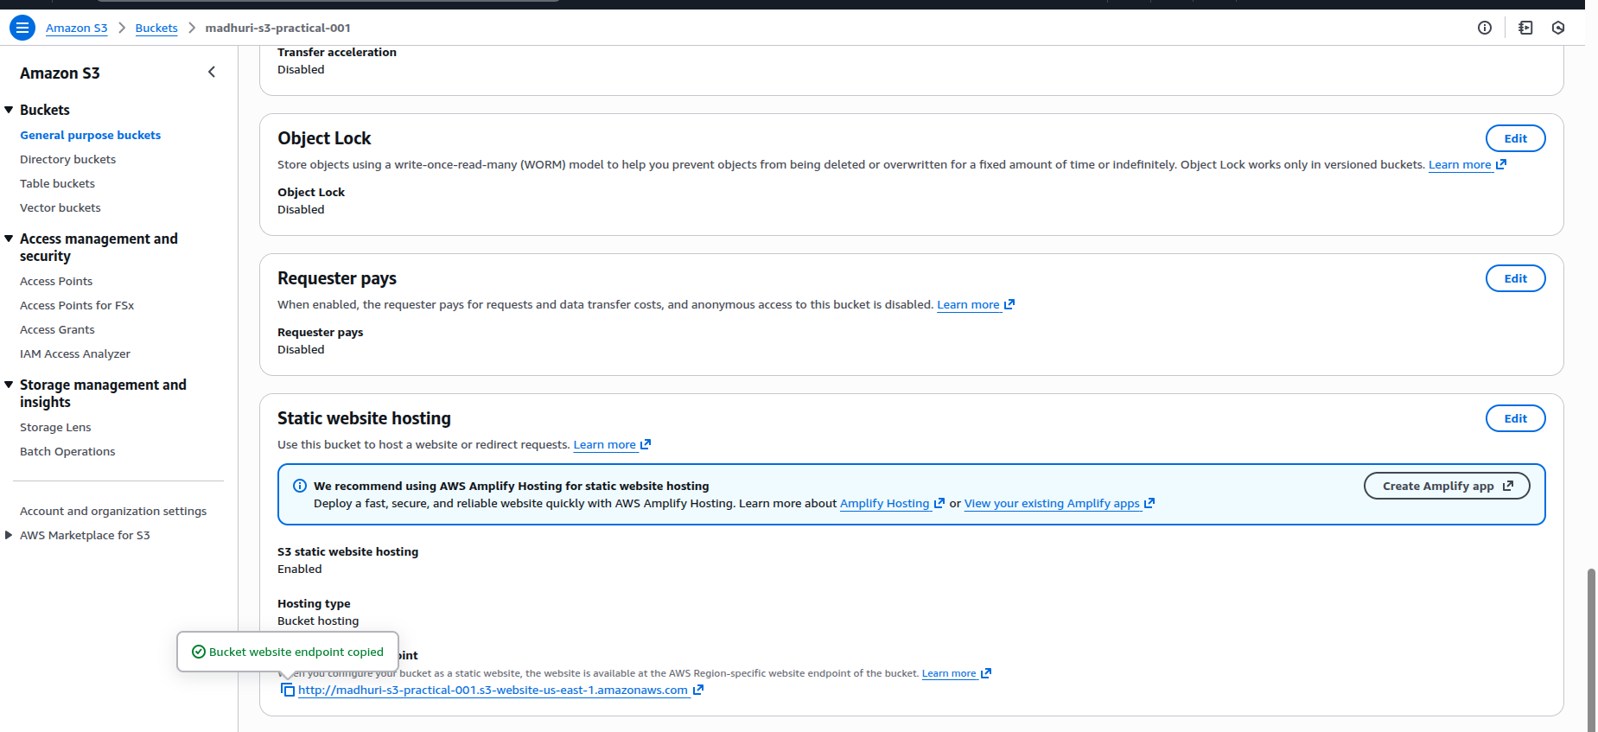 paste in Browser
